**Global Multi-Factor Authentication (MFA)**

This SOP provides a detailed guide for administrator to manage the Global Multi-Factor Authentication (MFA) settings, allowing them to enable or disable MFA for Store Managers (SM) across the system. This process is exclusive to higher authorities (admin).

**Process Overview:**

Global MFA configuration gives administrator the ability to control whether Store Managers are required to use multi-factor authentication. Here are the step-by-step instructions for enabling and disabling this feature:

* **To Disable Global MFA:**

**Step1: Access the Admin Panel:**

-Log in to the system using your admin credentials to access the admin panel.

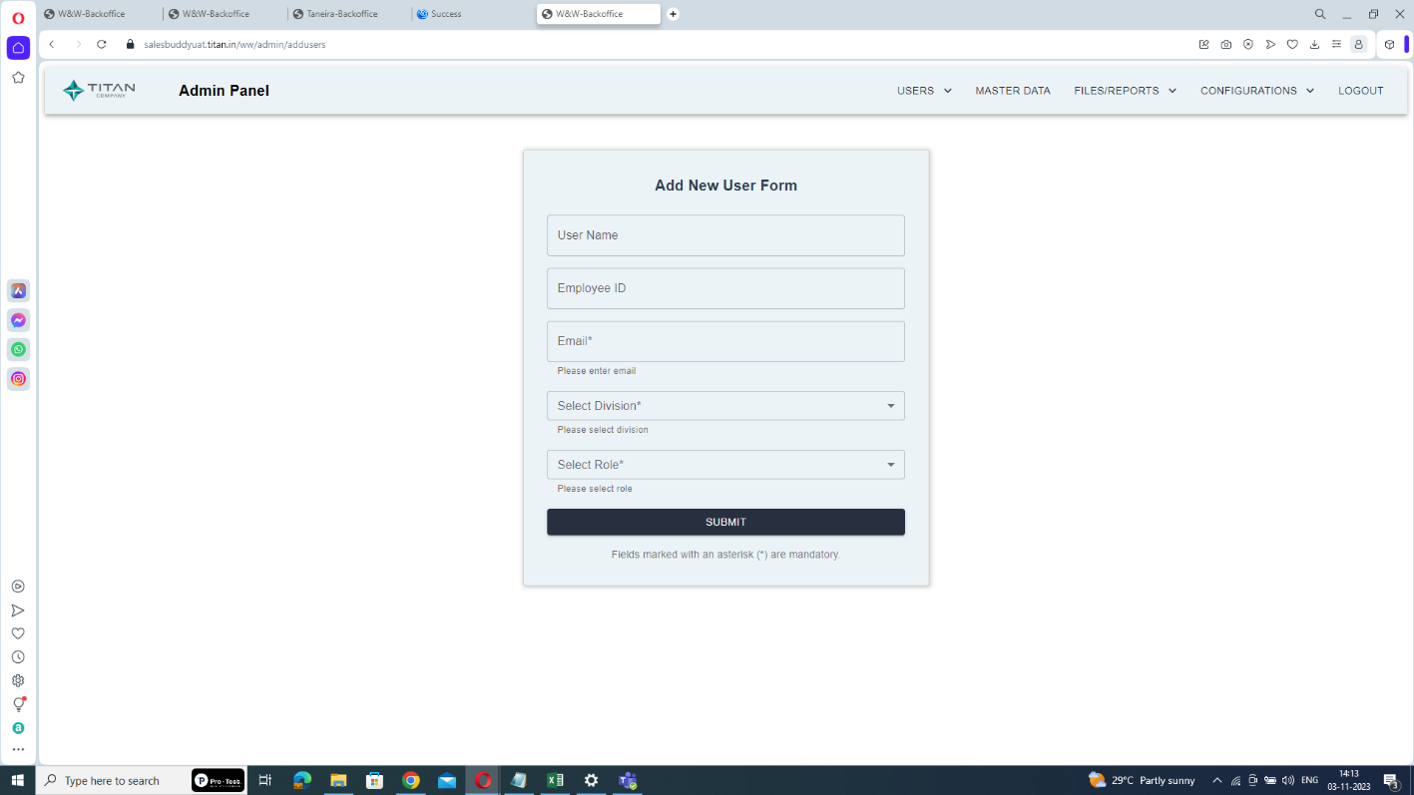

**Step2: Navigate to Configurations:**

- Within the admin panel, locate and select the "Configurations" section.

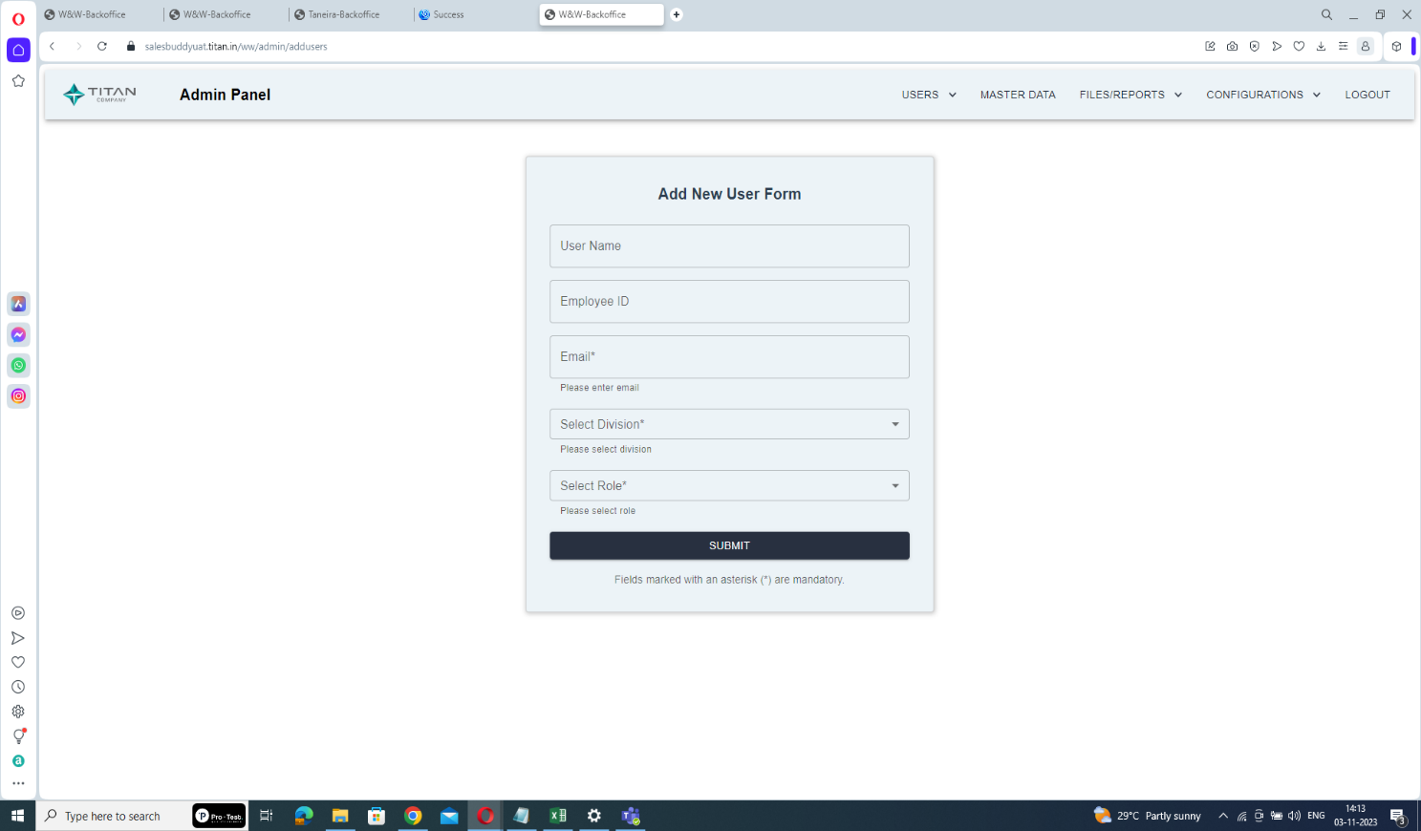

Click here

**Step3: Access MFA Configuration:**

- In the Configuration section, find and click on "MFA Configuration".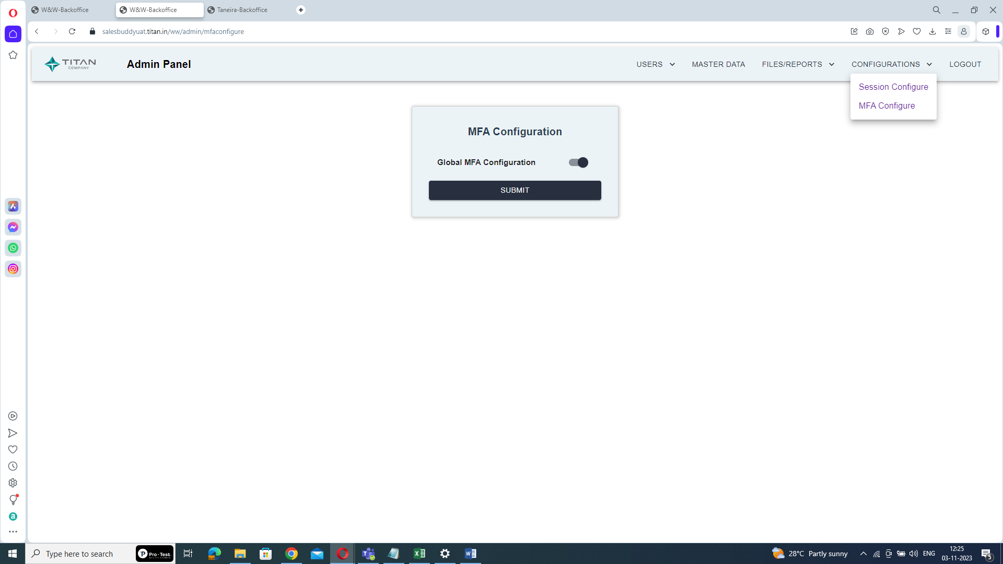

Click here

**Step4: Switch to Disable Mode:**

- within the MFA Configuration settings, locate the Global MFA Configuration option and switch it to "Disable".

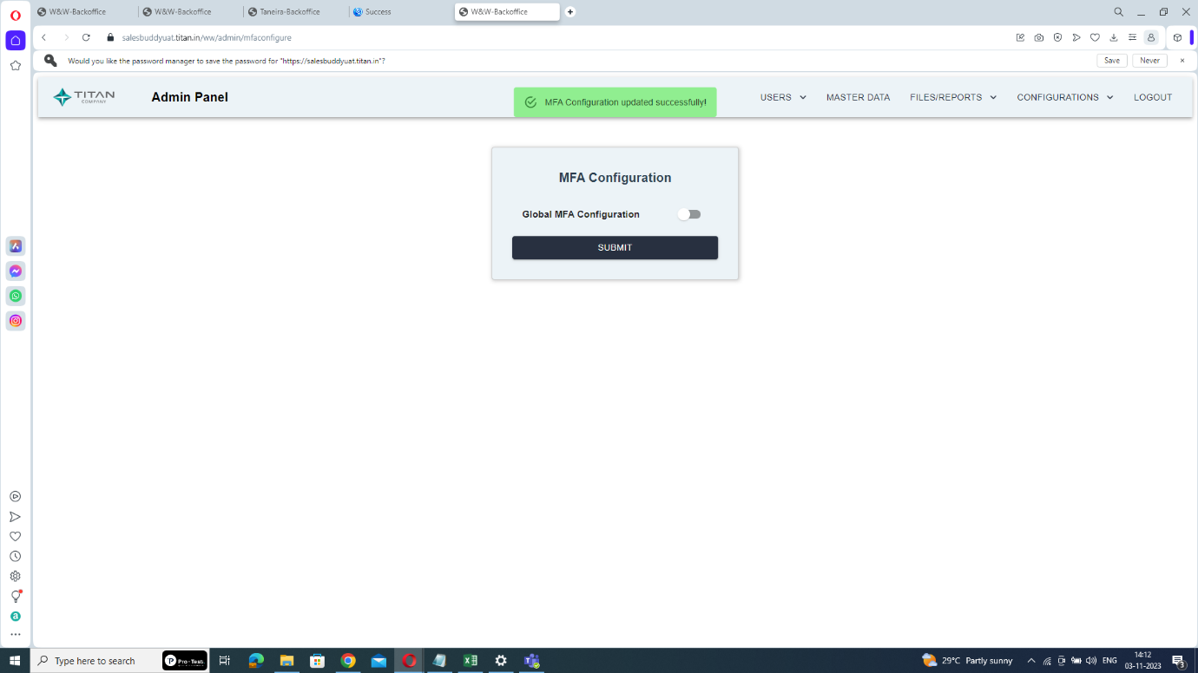

Disable here

**Step5: Save the Changes:**

- After switching to Disable mode, click the "Submit" button to save the changes.

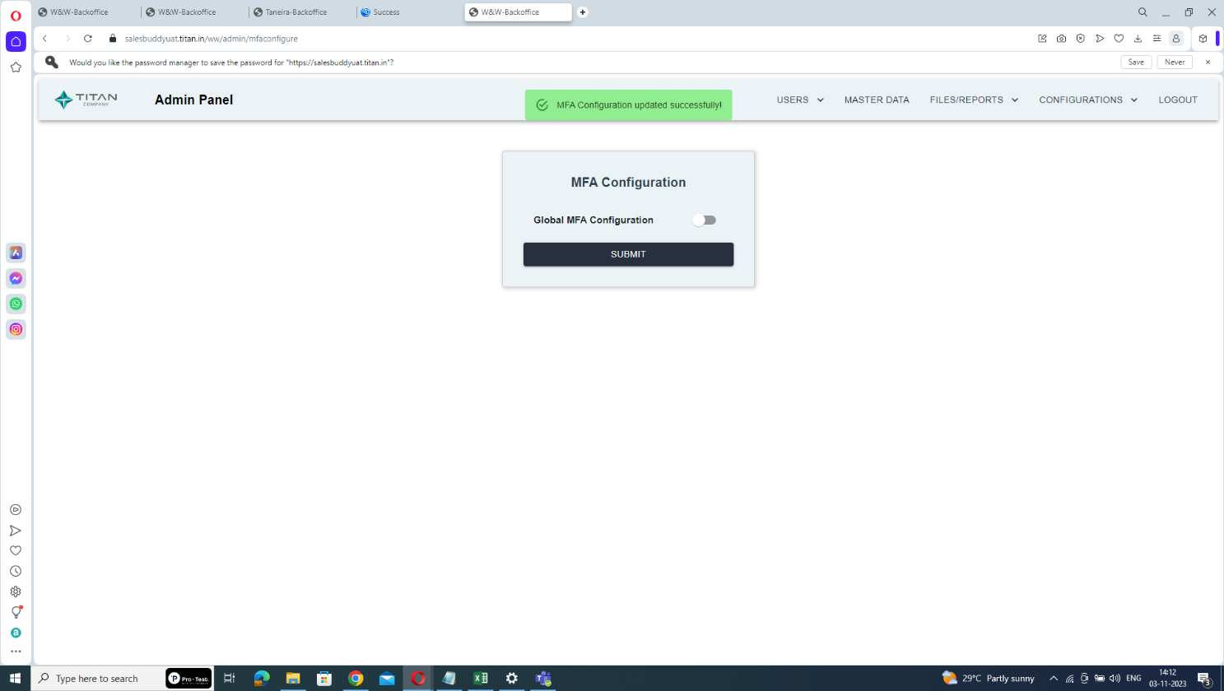

Click submit

By disabling Global Multi-Factor Authentication, all Store Managers (SM) will be able to log in directly using their usernames and passwords, without the requirement of enrolling in the multi-factor authentication process.

* **To Enable Global MFA:**

**Step1: Access the Admin Panel:**

- Log in to the system using your admin credentials to access the admin panel.



**Step2: Navigate to Configurations:**

- Within the admin panel, locate and select the "Configurations" section.



Click here

**Step3: Access MFA Configuration:**

- In the Configuration section, find and click on "MFA Configuration".

Click on MFA Configure

**Step4: Switch to Enable Mode:**

- within the MFA Configuration settings, locate the Global MFA Configuration option and switch it to "Enable".



Enable here

**Step5: Save the Changes:**

- After switching to Enable mode, click the "Submit" button to save the changes.

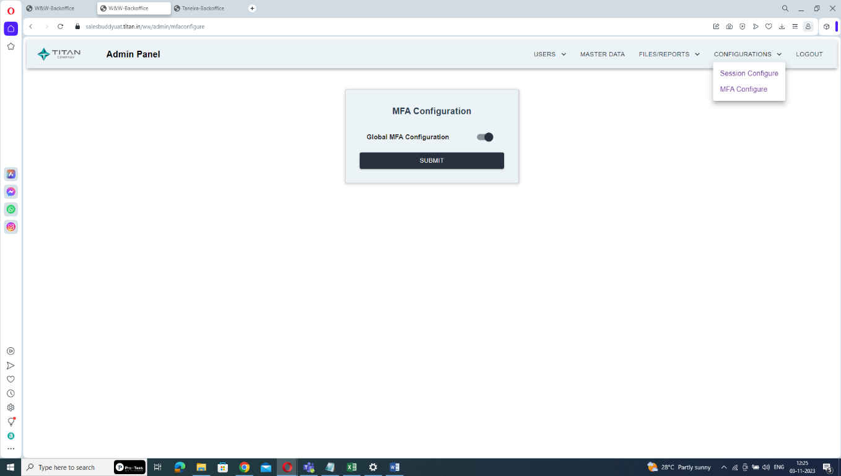

Click submit

Once Global Multi-Factor Authentication is enabled, Store Managers (SM) will be required to enroll in the multi-factor authentication process in order to log in, enhancing the security of their access to the system.

By following these steps, administrator can efficiently manage Global MFA settings, providing flexibility in implementing multi-factor authentication for Store Managers as needed.